NAVICP Opportunity Index

Overview
The NAVICP Opportunity Index (OI) is a tool that categorizes and prioritizes weapons systems in order to identify those systems with significant supportability challenges. The Opportunity Index is split into two different levels to identify supportability challenges: LECP (NIIN level) and PBL (System Level).

The Opportunity Index
The Opportunity Index uses aviation maintenance data (5 quarters) and NAVICP logistics data to identify items with logistics and/or support challenges. The maintenance data comes from a CRCS/CADS scrubbed output and is matched with NAVICP Oracle tables along with Opportunity Index maintained tables. The inputs are used to calculate indices/ factors that relate to supportability issues, reliability issues, and obsolescence issues. In keeping with the structure of indexing, the highest value a particular index/factor can have is 1 and lowest is 0. Therefore, the closer a particular factor is to 1 identifies the opportunity to improve in the performance of the NIIN or System. The LECP and PBL OIs are broken out by IWST and Overall (All of the IWSTs) to determine where improvement exist within an IWST and throughout the building. Cogs included in the analysis are 7R, 4Z, 6R and 6K.

LECP Opportunity Index
The LECP Opportunity Index utilizes three separate indices/factors based on the NIIN level: Depot Cost Index (DCI), Reliability Index (RI), and Failure Factor (FF). All of the NIIN level data is rolled up to the current head of family (HOF).

The DCI ranks the costs of repairing items during the reporting period, the RI ranks the items using a calculated MFHBF, and the FF is a ratio that is the number of BCMs to the total number of failures (BCMs + Repairs).

The LECP Cost OI and Reliability OI use different weighting factors of the DCI, RI, and FF to produce a ranking of the systems based on cost and reliability opportunities.

- Cost OI weighting factors are: DCI (70%), RI (15%) and FF (15%)
- Reliability OI weighting factors are: DCI (15%), RI (70%) and FF (15%)

PBL Opportunity Index
The PBL Opportunity Index utilizes four separate indices based on the System Level (4 Digit WUC):
- Depot Cost Index (DCI) – costs of repairing systems during the reporting period
- Reliability Index (RI) – ranked using a calculated MFHBF
- Supportability Index (SI) – ranked using Backorder and Demand data
- Obsolescence Index (OBI) – uses family existence, individual items age, and the Federal Stock Class (FSC ) to rank the obsolescence profile of the system

The PBL Cost OI and Reliability OI use different weighting factors of the DCI, RI, SI and OBI to produce a ranking of the systems based on cost and reliability opportunities.

- Cost OI weighting factors are DCI (60%), RI (20%), SI (5%) and OBI (15%)
- Reliability OI weighting factors are DCI (20%), RI (60%), SI (5%) and OBI 15%)

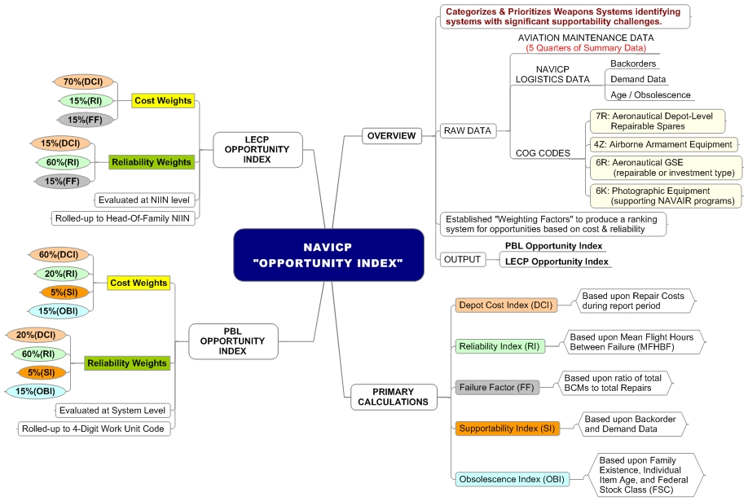
Figure 1 Opportunity Index Mindmap

